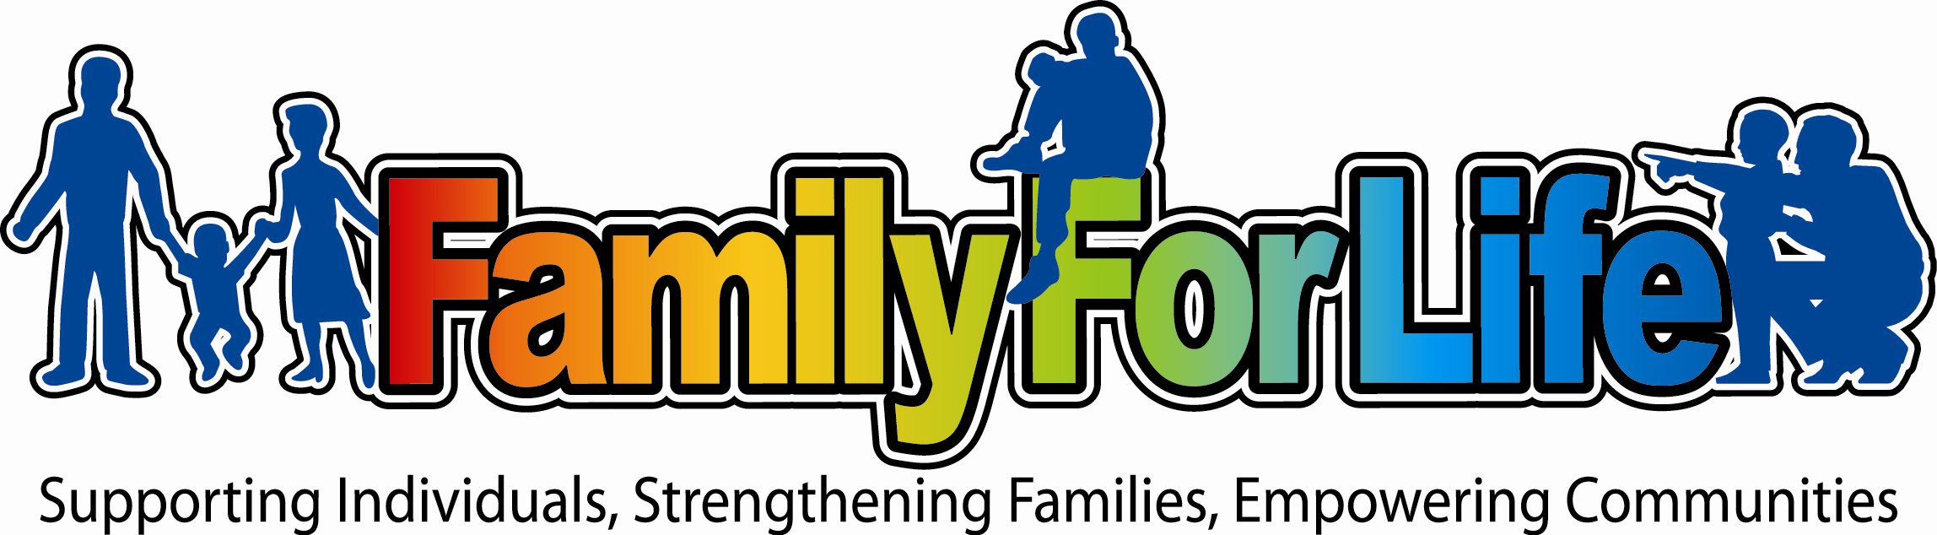

350 N. Guadalupe St. Suite 140-255 San Marcos, TX 78666 (512) 393-9369

To Whom it May Concern,

Family for Life fully supports the work of Dr. Angela Ausbrooks. She will be conducting research and evaluation for our Camp Family4life program, which reunites separated siblings of foster care and adoption. We agree and approve of her work on our behalf. She will conduct interviews and other data collection with the stakeholders of our program including foster parents, participants, staff, volunteers and Board Members. If you have any questions, feel free to contact me at (512) 393-9369 or by email at info@family4life.org.

Sincerely,

Rob R. Rodriguez
Founder/Director
Family for Life
www.family4life.org

